For testing:

Step 1: Run Mqtt Broker in , make sure broker should running

Step 2: Open Intell Realsense viewwe and activate firmware log

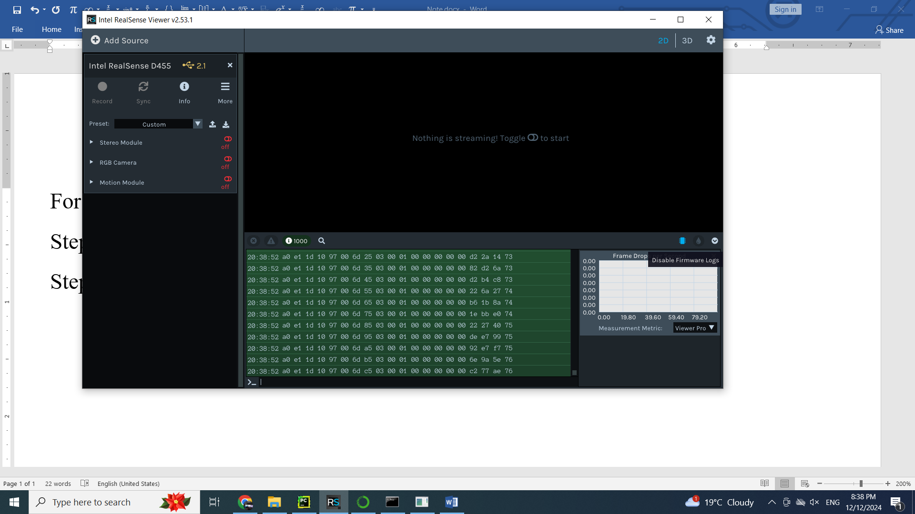

3. Run python program and start each camera

Done by Ky